4.2 Ideas Help Start a Revolution
- Tensions increase throughout the __________________until the ___________________ declares _________________________________________on July 4, 1776.
- The Colonies Hover Between Peace and War
  - The Second Continental Congress
• Second Continental Congress meets May–June 1775 in____________________:
- _______________________________________________
- _______________________________________________
- _______________________________________________
- ________________________________________________
  - The Battle of Bunker Hill
• ___________________troops attack __________north of Boston, June 1775
• Costly British win: ________________________________________________
  - The Olive Branch Petition
• July, Congress sends ____________________________to restore “harmony”
• George III rejects petition, orders ____________________________________
- The Patriots Declare Independence
  - Common Sense
• Thomas Paine’s pamphlet _______________________________attacks king
• Argues independence will allow _____________________________________
• Independence can give equal_____________, _______________opportunities to all
• Almost_________________________________________; convinces many colonists
  - Declaring Independence
• _______________urges each __________________to form own government
• Congress appoints ________________to prepare ___________________________
• Virginia lawyer _______________________________chosen to write it
• Declaration of Independence—__________________________________________
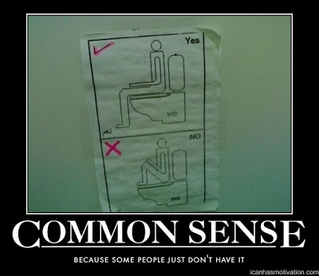
  - Declaring Independence
• Declaration, based on _____________________ideas, lists complaints, _________:
- _________________________________________________________
- _________________________________________________________
- _________________________________________________________
• “____________________________” means free citizens are political equals
• ___________________delegates adopt declaration

- Americans Choose Sides
  - Loyalists and Patriots
• Loyalists—_____________________________________________________________:
- ________________________________________________________________
• Patriots, almost ________of population, support __________________________:
- ____________________________________________________________

  - Taking Sides
• Groups divided: _______________________________________on both sides
• _____________________________support British; _____________threaten their lands
