4.4 Winning the War
- Strategic victories in the _______and at __________ enable the Americans to defeat the______
- European Allies Shift the Balance
  - Training the Continental Army
• 1778, ____________captain ______________________________goes to __________
• Trains _____________ in fighting skills, field _________________of regular ________
  - Lafayette and the French
• Marquis de Lafayette—___________________________________________________
• Lobbies for__________________, 1779; leads command in last ___________________
- The British Move South
  - Early British Success in the South
- 1778, British take_____________; royal governor reinstated in _____________
- __________armies capture________________, 1780—____________________
- British commander ______________________smashes through _____________
- ____________Americans escape _________ owners, join British to win _______
  - British Losses in 1781
- _______, Cornwallis fights_________________, ________________in ________
- Weakened _________________gets_________________, camps at __________
- The British Surrender at Yorktown
  - Victory at Yorktown
• French army lands in________________, Rhode Island in _______
• Lafayette’s plan: __________________________________________________
• French_________________________, _______________ Chesapeake Bay
• American, French siege________________, shell ________for three weeks
• Cornwallis ____________________________________________
  - Seeking Peace
• 1782 peace talks include_________________, __________, __________, __________
• American negotiators: John Adams, Benjamin Franklin, John Jay
• ________________signed September_______:
- ________________________________________________________________
- ________________________________________________________________
- ________________________________________________________________
- ________________________________________________________________
-_________________________________________________________________
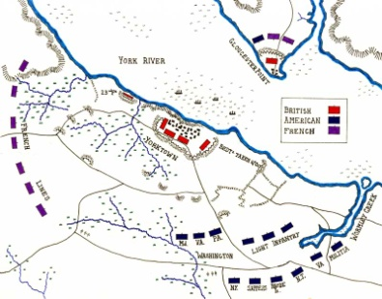
- The War Becomes a Symbol of Liberty
  - The Impact on American Society
- War stimulates___________________—________________________________
- Equality for____________; women do not gain ___________________________
- African Americans still _____________; those free face ____________________
- _________in upper South debate______________________; some free ______
- _____________________continue to be forced off their ___________by settlers
  - The Challenge of Creating a Government
- U.S. attempts to create ______________________________________________
